**Package Management YUM REPO**

**Configuring Local Yum Repository:**

1. **Check whether the iso file is attached to the system by lsblk command**

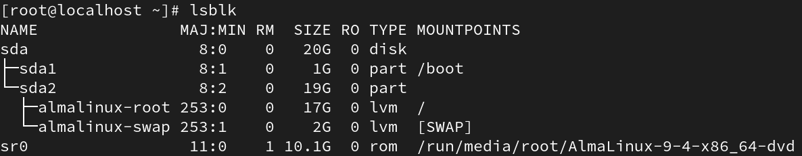

1. **Make a directory in /var/ftp/dog/AppStream**

**Make another directory in /var/ftp/dog/BaseOS**



1. **Copy the directory from**  **cp -r /run/media/root/CentOS-Stream-9-BaseOS-x86_64/AppStream/Packages/ to /var/ftp/spvp/Appstream/**



**Same as to BaseOS**



1. **Check whether the yum installed or not, if it not installed then install it using yum install createrepo_c-libs.x86_64**

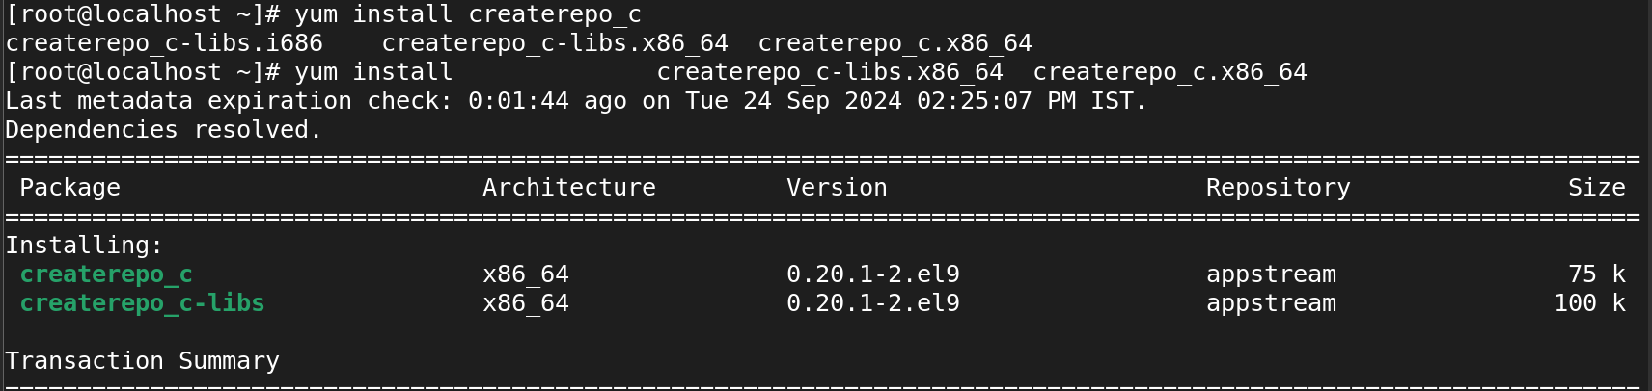

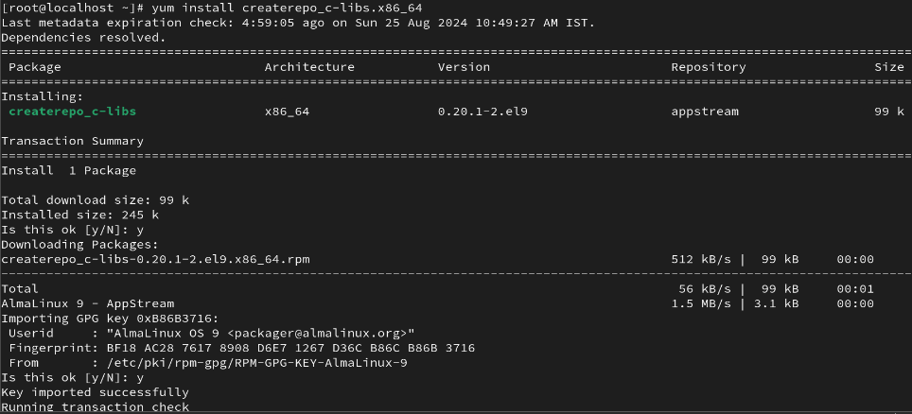

1. **Once Createrepo Command In Available Then Create Repository**

**createrepo -v /var/ftp/spvp/AppStream/Packages/**

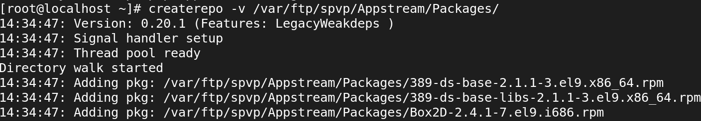

**createrepo -v /var/ftp/pub/BaseOS/Packages/**

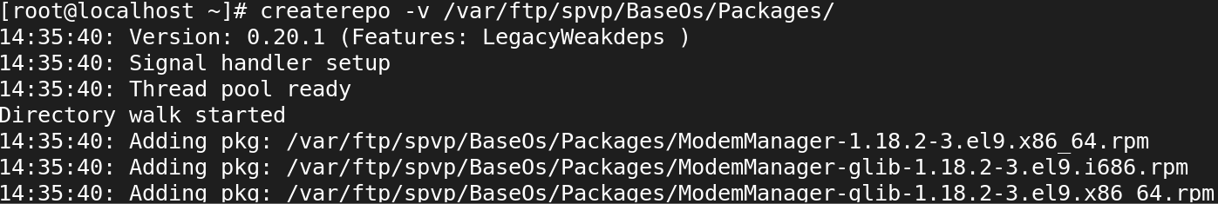

1. **create the repository configuration file in “/etc/yum.repos.d” directory and make sure it has the “.repo” extension. And move the other repo files to another directory.**

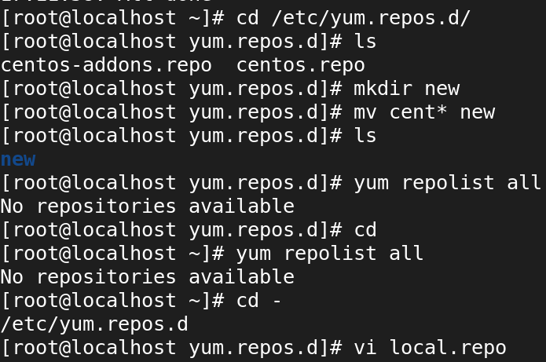

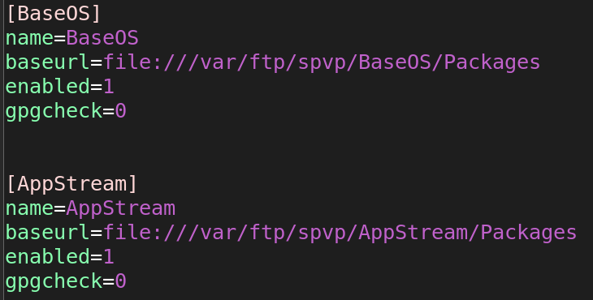

1. **confirm the repository has been configured.**

**yum repolist list all**

**yum clean all**

**yum install nfs-utils**

**yum install samba**

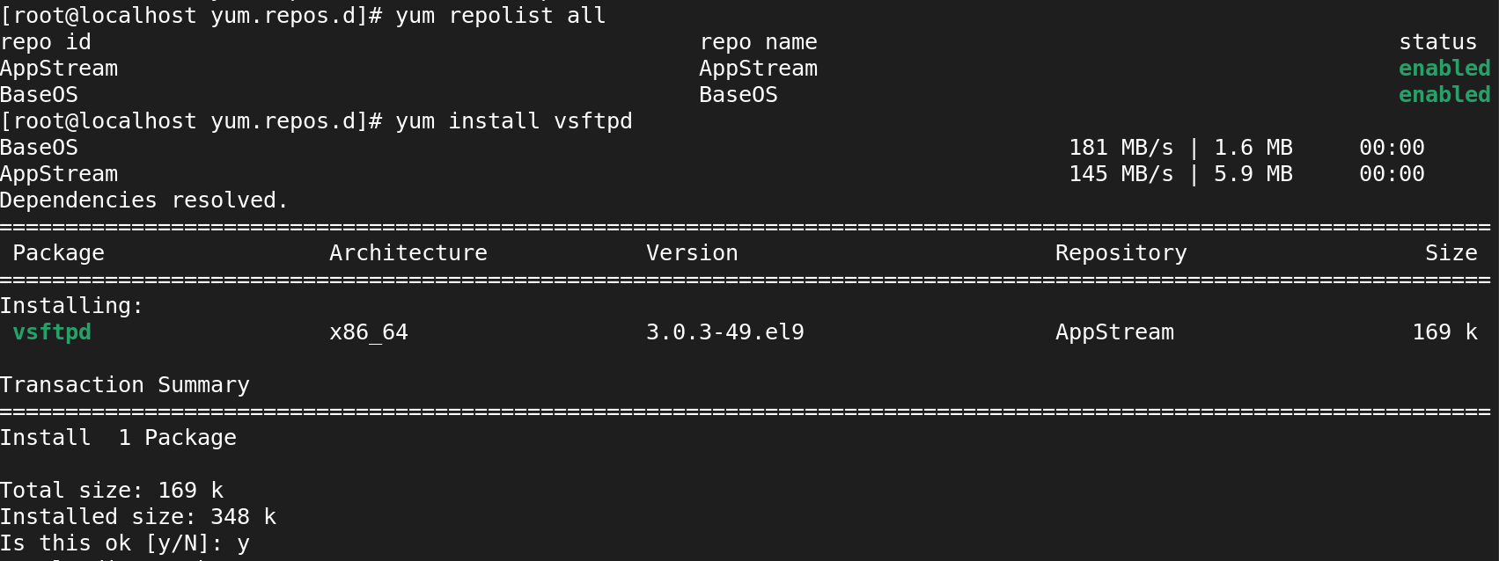

**If It is Located in the FTP Server:**

**Follow the given instruction given below:**

* **Install vsftpd**
* **Disabling Firewall**
* **Enabling VSFTPD services**
* **Disabling SELINUX**

**Process: Disabling Firewall**

**Systemctl status firewall.service**

**Systemctl stop firewall.service**

**Systemctl disable firewall.service**

**Process: Enabling vsftpd.services**

**Systemctl status vsftpd.service**

**Systemctl start vsftpd.service**

**Systemctl enable vsftpd.service**

**The above both process was given below screenshot.**

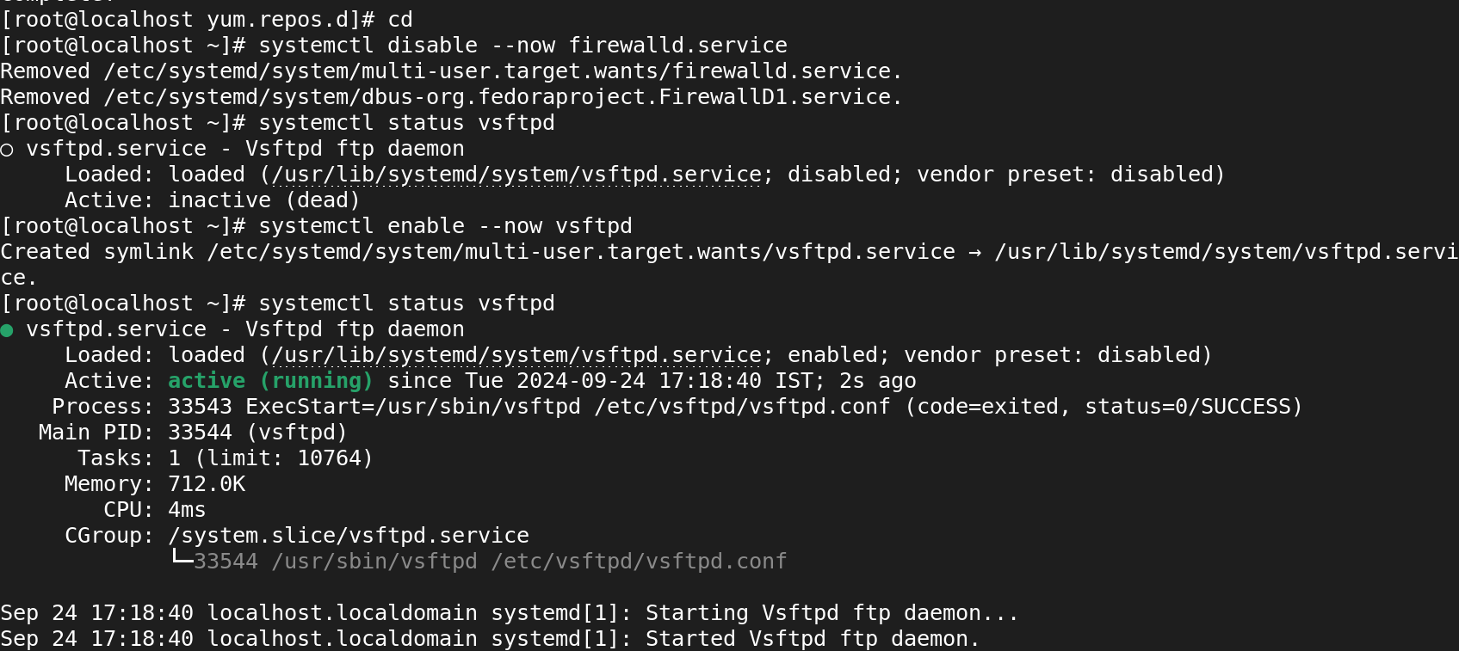

**Getenforce**

**Vi /etc/selinux/config**

**Disabling selinux**



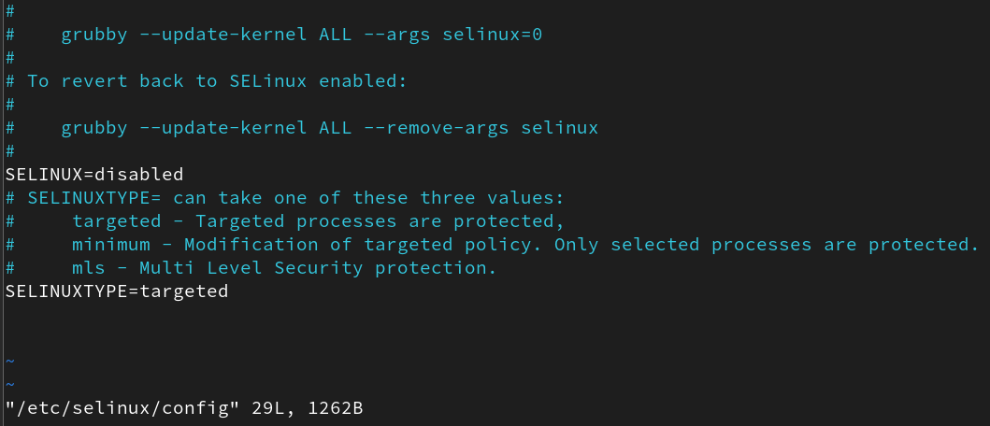

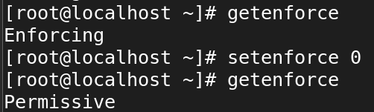

**Vi /etc/vsftpd/vsftpd.conf**

**Enabling anonymous**



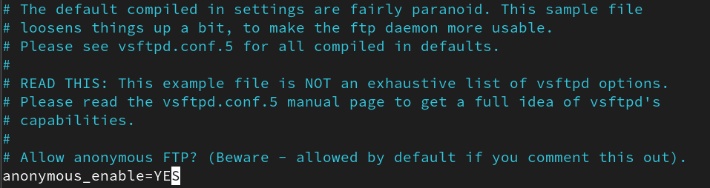

**Restarting vsftpd.service**



**Configuring ip address of server**

**ifconfig**

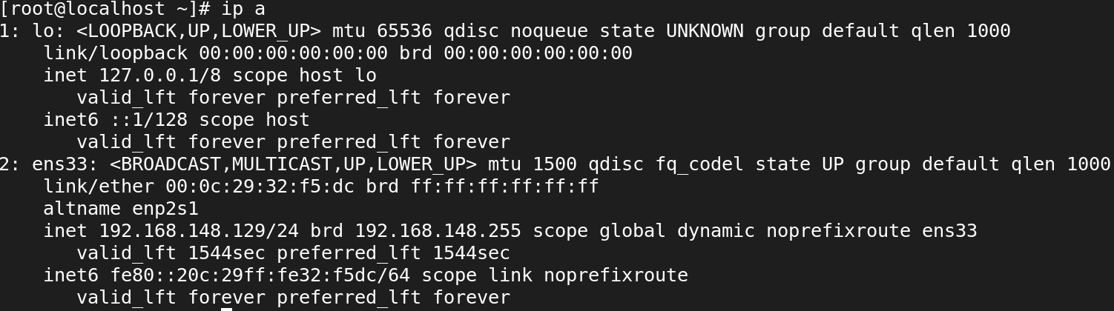

**Client**

**Same what we did in server here,**

**cd /etc/yum.repos.d**

**Move the files to the another directory which is in the config directory.**

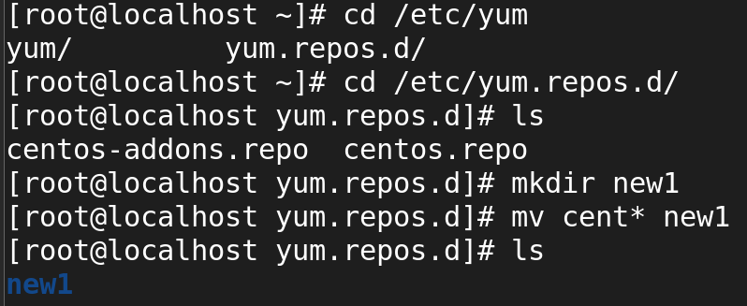

**Creating a new config file**

**vi cat.repo**

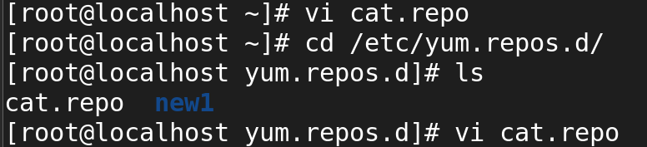

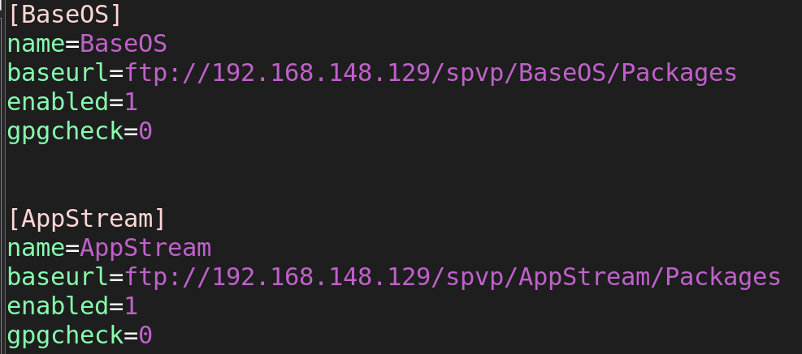

**Install package when u in offline**

